VOLUME 41 I June 2023

In this edition

A message from Michelle McDonald 1
Welcome to Open Place 3
Anniversary Forced Adoption Apology 4
Mothers who lost their children to
adoption fund 5
Centre for Women’s Economic Safety 5
Older Persons Advocacy Network 6
Energy relief bonus 7
Former Residents’ Reunions 8
Uniting Heritage Service updates 9
Counselling and Redress update 10
Records team update 12
Drop-in centre 12
Social support group updates 13
Butterscotch pudding recipe 21
Contact us 22

A message from Michelle McDonald,
Senior Manager Open Place
The year has started with high demand across all our programs and new registrations with the service also growing.
This demand, along with some staff illness and team changes, has meant that we now have wait times for some programs as well as delays with some of our call backs. We are working hard to minimise these wait times and appreciate your patience and understanding
In staffing changes, we have sadly said goodbye to Sue (Counselling), Virginia (Redress) and Kate (Reception), and you will see on page 3 that some new team members have joined us. We will continue to recruit to a number of positions over the coming months.
I know many of you are waiting to hear more details in relation to the Victorian Government Redress Scheme. We do not have any further updates at this point in time, but once available, updates will be published on the Victorian Government Department of Families, Fairness and Housing (DFFH) website at https://services.dffh.vic.gov.au/pre-1990-care-leavers and on the Open Place website.
In April, I attended the Alliance for Forgotten Australians forum in Brisbane. The Alliance has made some changes to their Constitution with the Board now made up almost completely of Forgotten Australians, as well as one independent member State and Territory Find and Connect Service are Affiliate Members. I represent Victoria’s Find and Connect Service, Open Place

The Alliance attended Brisbane’s Parliament House for the launch of the National Aged and Community Care Roundtable for Forgotten Australians website. The new website brings together resources about specialist support services, aged care, advocacy, government, research/reports and personal stories of Forgotten Australians. http://www.forgottenaustraliansroundtable.com.au/
The Alliance also visited Lotus Place, the Queensland Find and Connect Service for Forgotten Australians in Brisbane. This was a wonderful opportunity to connect, look at common themes and to see how other services are operating. A photo of the Alliance with Lotus Place staff and service users is below.
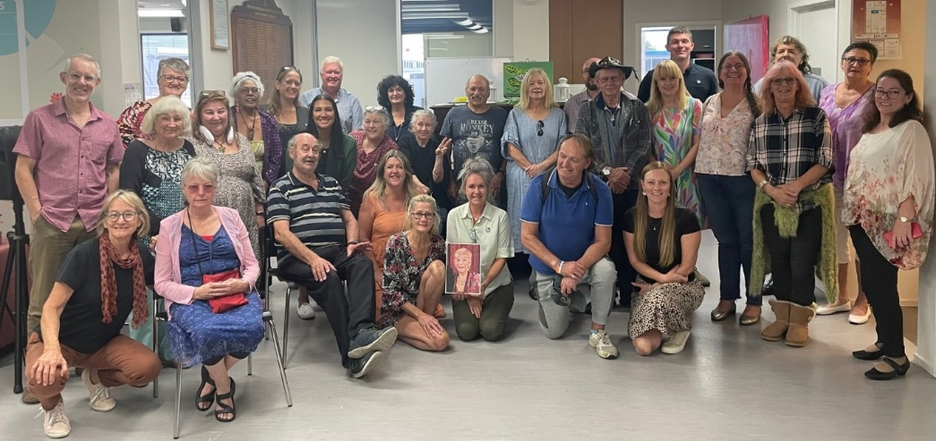

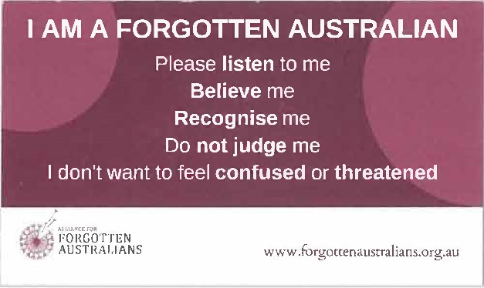
In response to your feedback, the Alliance has produced a reworded ‘I am a Forgotten Australian’ wallet card for you to use. The card includes a QR code that will take people to the Alliance website where there are many resources to assist people to gain an understanding of Forgotten Australians.
If you receive our newsletter via post, you will have received a printed copy of the card along with this edition. If you receive our newsletter via email and you would like a printed card, please call us on 1800 779 379.
The Alliance is also developing a poster that can be left at different services with the same QR code on it.
For more information on the Alliance please visit their website at https://forgottenaustralians.org.au or visit https://bit.ly/AFA-News to subscribe to their new newsletter.
As winter is fast approaching, stay warm and healthy.

Michelle
Senior Manager Open Place

Welcome to Open Place
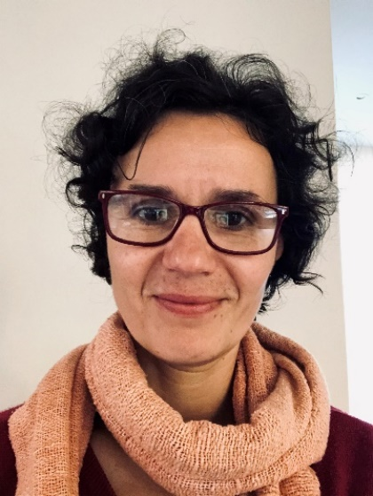
Lejla, Senior Counsellor
My name is Lejla and I joined the Open Place team in February. I am a counsellor with experience in working with survivors of sexual assault, family violence, drug and alcohol abuse and mental health difficulties, both in Australia and overseas. I am passionate about supporting people who have experienced long-term and significant trauma to feel empowered in their own lives.
Most recently I worked as a counsellor at the Centre Against Sexual Assault at the Royal Women’s Hospital both in the ongoing and crisis counselling roles.

Rose, Redress Support Worker

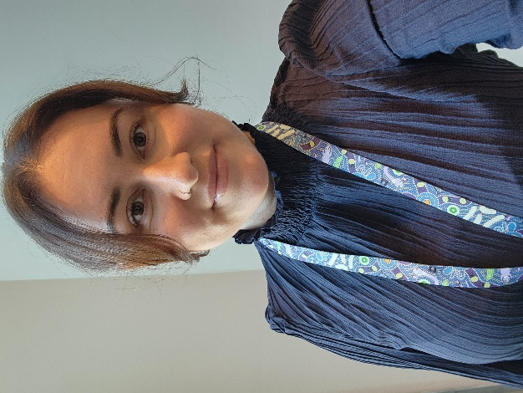
My name is Rose and I joined the Redress team at Open Place in May.
I am a social worker, and have previously worked across the family services, family violence and youth work sectors. I have spent the last few years supporting victim survivors of family violence, and I am passionate about supporting people in their journeys of healing and recovery.
I look forward to meeting more of the Open Place community in the coming weeks.

Janelle, Redress Support Worker
My name is Janelle and I recently joined Open Place at the end of
April 2023 as a Redress Support Worker.
I previously worked as a Psychosocial Support Worker in acute mental health in a suicide prevention program. In this role, I worked closely with individuals experiencing a suicidal crisis. I worked within a multidisciplinary team consisting of social workers, mental health nurses and psychiatrists.
Prior to this role, I worked as a Forensic Case Manager within the forensic system, where I worked closely with individuals exiting prison back into the community.
I’m looking forward to being a part of the team here at Open Place and working alongside people at the drop-in centre.
10th Anniversary of the National Apology for Forced Adoptions
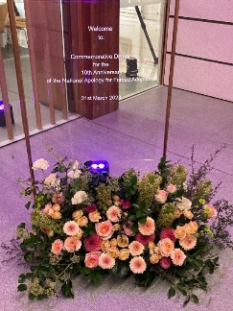
Marking the anniversary on Tuesday 21 and Wednesday 22 March 2023
Diane, Records, Find and Connect Worker
Tuesday 21 March 2023 marked the 10th anniversary of the National Apology for Forced Adoptions. The National Apology acknowledged the lifelong pain and suffering associated with forced adoption* practices and committed to supporting all those affected to get the help they need.
Guests were invited from all states and territories with airfares and accommodation arranged and paid for by the Australian Government Department of Social Services. Approximately 200 people attended.
I was fortunate to receive an invitation to the anniversary event from one of the local adoption support organisations as I had attended the National Apology in 2013 when in the employ of VANISH. I was happy to accept as quite a number of our Forgotten Australians are also mothers, fathers and adopted children whose adoptions weren’t always the happy ‘fairy-tale’ that their mothers were told it would be.
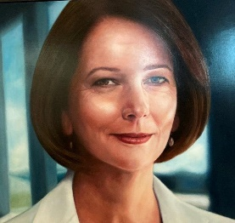
Guests were invited to attend a commemoration dinner held at the National Portrait Gallery on Tuesday night, with speeches given by the Hon Amanda Rishworth MP (Minister for Social Services), the Hon Nicola Roxon (former Attorney-General) who spoke on behalf of the Hon Julia Gillard AC who was in London and unable to attend due to contracting COVID-19, and Professor Nahum Mushim (Chair of the Apology for Forced Adoptions Reference Group). Other attendees were Attorney-General the Hon Mark Dreyfus KC MP, the Hon Jenny Macklin (former Minister for Families, Housing, Community Services and Indigenous Affairs, and Minister for Disability Reform), Rachel Siewert (former Senator and Chair of the Senate Committee at the time of the Apology) and the Hon Rachel Stephen-Smith MLA (Australian Capital Territory Minister for Health, Minister for Families and Community Services, and Minister for Aboriginal and Torres Strait Islander Affairs).
Portrait at Parliament House of the Hon Julia Gillard AC

Prior to the dinner, a panel discussion arranged by the National Archives of Australia was held entitled ‘Saying sorry: Do national apologies change the world?’. The Welcome to Country, which was given by Paul Girrawah House at the commencement of the proceedings, included historical information about First Australians living in the area prior to and at the time of white settlement.
The panel consisted of the Adjunct Professor the Hon Nahum Mushin AM (Chair of the Australian Government’s Forced Apology Reference Group in June 2012), the Hon Jenny Macklin (had oversight of the Apologies to the Stolen Generation and Forgotten Australians), Rosemary Baird (Sub-Committee of National Sorry Day Commission) and Professor Michelle Arrow (Vice-President of Australian Historical Association).
The takeaway message was that apologies are important because they acknowledge the experiences of people who have been harmed and (hopefully) promote healing; possible reparation and activism – the general public must know the truth of what has happened. Unfortunately, at the time of the 2013 Apology for Forced Adoptions, it did not get the country-wide publicity/education that it deserved due to the political climate at the time, when there was a push to ’oust’ the then prime minister the Hon Julia Gillard AC.
On Wednesday morning, guests were transported to Parliament House and admitted to the House of Representatives for a Statement of Significance given by the Hon Amanda Rishworth MP. The Shadow Minister, Hon Michael Sukkar MP also spoke. It was advised that the Australian Government continues to provide $1.8mil annually. An additional $700,000 would be allocated for training for Aged Care, Allied Health and Forced Adoptions Support Services providers. There was a mixed response to this announcement.
* The term ‘Forced Adoption' refers to adoptions where there was coercion, manipulation, illegality, and/or lack of support.
Please see below information relating to the Exceptional Circumstance Fund for Mothers who have lost their child/children to adoption.
Diane
Mothers who lost their children to adoption prior to 1985
Victorian Government Exceptional Circumstances Fund
The Victorian Government has provided a one-off payment of up to $10,000 to mothers affected by forced adoption policies and practices in Victoria. The Forced Adoption Exceptional Circumstances Fund is designed to support mothers with exceptional circumstances before the Redress Scheme is established. It will not replace or affect future applications to the scheme.
Exceptional circumstance can include:
- critical or terminal illness (priority)
- diagnosed mental illness
- having one or more chronic conditions
- chronic health conditions, surgery for mobility issues or other elective surgery
- having experienced an injury or other debilitating event that has materially impacted on physical or psychological wellbeing
- other exceptional circumstances that are likely to significantly impact you in the next 12 months.
Any mother who lost her child/children to adoption and would like advice around making an application for the exceptional circumstances fund, please phone 1800 779 379 and ask to talk with one of the Open Place Coordinated Support Workers.

Free Centre for Women’s Economic Safety (CWES) Money Clinics
Are you feeling overwhelmed by money issues?
Would you like money information to be provided in a way that suits you and at your pace from someone that understands the impact of financial or economic abuse?
Want to know more about your money options so that you can create and reach your goals for you and your children?
If your answer is ‘yes’, CWES Money Clinics could be for you.

Who are Money Clinics for?
CWES’s free Money Clinics are for women, gender diverse or non-binary people living in Australia who have experienced family or domestic violence and want to talk about money issues – no matter how big or small.
There are NO residency status requirements, or income, assets or geographic eligibility criteria.
What is offered?
- Up to an hour-long session to work through what is important to you. There is no minimum or maximum number of sessions.
- Quick access – In most cases, Money Clinics can see you in under one week.
- Qualified and informed staff – all Money Clinic workers are women who are qualified financial counsellors with training to support victim-survivors of family and domestic violence.
- Information, support, and referrals based on your stated needs and goals. CWES work with you to understand your money priorities and the pace you want to go at, and share relevant information to support your goals.
Making an appointment
- CWES Money Clinics are offered in-person in Sydney and Melbourne, or online via Zoom.
- You are welcome to bring a support person to your appointment.
- Contact CWES directly to book or get more information. Phone: 1800 730 031 (free call), Email: MoneyClinics@cwes.org.au
- You do not need to register or record your personal details to access a Money Clinic.
About CWES For more information, visit www.cwes.org.au or www.financialsafety.org.au

The Older Persons Advocacy Network
The Older Persons Advocacy Network (OPAN) offers free, face-to-face education and information sessions for older people, their friends, family and representatives receiving aged care services, to support informed decision making. Their advocates can teach you about your rights when receiving Australian Government-funded aged care services, and how OPAN can support you to access aged care and resolve any issues or concerns with your aged care service.
Knowing your aged care rights and understanding how to navigate the aged care system supports a better care experience.
Book your session via the website https://opan.org.au or call 1800 700 600 for more information.
OPAN can also provide free education sessions to community groups interested in learning more about rights in aged care, including those considering their aged care options.
If you attend a Social Support Group and are interested in having an education session at your group, please call Open Place on 1800 779 379 and ask to speak to the staff members who attend your group.
Energy relief bonus
The federal budget is providing $500 for energy relief for eligible Victorians

The first part of this funding is a $250 Power Saving Bonus
The Power Saving Bonus is a $250 payment for Victorian households to help ease cost-of-living pressures and encourage them to compare energy offers and save money.
The Bonus is available to all Victorian households who visit the Victorian Energy Compare website https://compare.energy.vic.gov.au or engage with an energy affordability service through one of our participating community outreach partners https://compare.energy.vic.gov.au/psb-outreach

When can eligible households apply for the next round of the $250 Power Saving Bonus?
Eligible households can apply for the next round from 24 March 2023. The Bonus is available to all Victorian households who visit the Victorian Energy Compare website or engage with an energy affordability service through one of our participating community outreach partners.

Is there a limit on how many $250 Bonuses are available?
During each round of the Power Saving Bonus Program, only one payment is available per household.

Will the $250 Bonus be deducted from my electricity bill?
No, the Bonus will be paid to your nominated bank account via Electronic Funds Transfer (EFT) or bank cheque.

I received payments through previous rounds of the Power Saving Bonus Program, can I apply for the new $250 Power Saving Bonus?
Yes, if you received payments under previous rounds of the Power Saving Bonus Program you are still eligible to apply for the new round, provided you meet the eligibility requirements.

Can my household apply for the $250 Power Saving Bonus more than once?
Only one payment per household is available for each round of the Power Saving Bonus Program.

Eligibility

Who is eligible for the $250 Power Saving Bonus?
The $250 Power Saving Bonus is available to all Victorian households. To be eligible for the $250 Power Saving Bonus, Victorian households will need to:
- Have a recent residential electricity bill.
- Be the account holder for that bill.
- Visit the Victorian Energy Compare website or engage with an energy affordability service through one of our participating community outreach partners.
The second part of this funding is a $250 energy relief payment paid directly to your energy provider and deducted from your bill.
Who is eligible for energy relief?
Generally speaking, it's for people on Centrelink payments and small businesses.
People will be eligible for energy bill relief through this measure if they:
- have a Pensioner Concession Card, (including those issued by the Department of Veterans' Affairs) (DVA)
- have a Health Care Card (including Low Income Health Care Card)
- have a DVA Gold Card
- have a Commonwealth Seniors Health Card (including those issued by DVA)
- get Family Tax Benefit (FTB) Part A or B
- get a Carer Allowance.
If you're not currently on these payments, it's worth checking out if you're eligible for them.
Do you have to apply for energy bill relief?
This will be automatic and customers do not have to do anything. However, it’s possible some people and businesses may need to have their eligibility confirmed.
Services Australia will contact customers from September 2023 if any action is required.
When will this come into effect?
The measure takes effect in the new financial year, on 1 July 2023.
Other states and territories have similar schemes and Coordinated Support workers can provide this information if you request it.
Former residents’ reunions
Calling all Victorian Children’s Aid Society care leavers
OzChild is committed to the ongoing support of all those who have been in their care throughout their 170+ year history.
For several years, the organisation has held an annual reunion event for those who resided at the Melbourne Orphanage and are seeking to hear from care leavers from the Victorian Children’s Aid Society for expressions of interest in establishing a reunion event for those interested in connecting with old friends.
Please contact Judi Vanderheiden, Administration Officer at OzChild via phone or email to express your interest.
Phone (03) 9695 2205 or email jvanderheiden@ozchild.org.au
Updates from the Uniting Heritage Service
Tally Ho reunion – help needed
The Heritage Service is planning a reunion in 2024 for people, and their families, who lived at Tally Ho in Burwood.
Uniting Heritage Service highly values the participation of former residents in reunions and other events. Recognising that living at Tally Ho was a difficult and traumatic time for some people, they are committed to making it a safe, respectful and meaningful event.
If you lived at Tally Ho before August 1986 and are interested in helping with this reunion, please contact either Chris Wade or Catriona Milne.
Chris Wade – 0481 469 899 | Catriona Milne – 0402 969 621
They are happy to talk with you about the event as involvement of those who lived there is important in its success.
Do you know these people?
The Uniting Heritage Service recently were given a photo from Tally Ho taken around 1963 or 1964 (pictured). If anyone recognises themselves or others, please contact Catriona Milne on 0402 969 621 with their names.

Kilmany Park commemoration event

A group of men who lived at Kilmany Park Farm Home for Boys is working with the Uniting Heritage Service to create a commemorative plaque.

This presbyterian home was just outside Sale, in Victoria, and operated from 1925 until the late 1970s. The plan is to unveil the plaque at an event for past residents and their families towards the end of 2023.

Any past residents or their families who may be interested to attend are very welcome to call Catriona Milne on 0402969621, or email her on Catriona.milne@vt.uniting.org

Counselling and Redress Support updates
Wait times
Due to a large demand for both Counselling and Redress Support, there is currently a waitlist for both services. We do acknowledge that people have faced significant wait times in recent months and appreciate people’s patience. We do our best to connect people with a Counsellor or a Redress Support Worker as soon as we can with the staff and resources we have. We understand it can be frustrating, and we welcome people calling in to check their progress on the waitlist. We appreciate you treating our staff with respect despite these frustrations.

Staff news
There have been quite a few changes to the team in recent months, so you might talk to or meet some new staff next time you call.
Sue Kilfeather finished up in her role as a Counsellor with Open Place. Sue worked in several teams across Open Place for many years, before settling into the counselling role. Sue is a highly experienced and skilled counsellor; as one Forgotten Australian commented, ‘Sue allows you to come to a point of recognising your own self. She really hears you… and that is really rare’. Sue will be greatly missed by the team and the people she supported during her time as an Open Place counsellor; we wish her all the best.
Virginia Carey has also finished up at Open Place. Many, many Forgotten Australians would know Virginia from her work at Open Place over the years, including supporting people who gave evidence at the Royal Commission into Institutional Responses to Child Sexual Abuse, and later assisting Forgotten Australians apply to the National Redress Scheme. Virginia is highly respected for her down-to-earth approach and her commitment to seeking justice and acknowledgement for people who suffered under the ‘care’ of institutions and the State. We hope Virginia is enjoying a well-deserved break while she plans her next move.
Lejla Arnautovic has joined us as Senior Counsellor. Lejla brings a wealth of experience supporting people who have experienced significant childhood trauma and will be providing counselling to Forgotten Australians and supervising the counselling team. She is looking forward to getting to know Open Place and Forgotten Australians over the coming months.
We also have 2 new staff who have just joined the Redress Support team - Janelle Hess and Rose Pearce - who you can read about on page 3 of this newsletter. They are both looking forward to settling into the team and will be ready to offer support with National Redress applications before you know it!

Redress Support team update
Our Redress Support team assists Forgotten Australians to apply for the National Redress Scheme, for people who experienced childhood sexual abuse in institutional ‘care’. Any Forgotten Australian considering making an application to the National Redress Scheme is strongly encouraged to get support, to ensure you get the best outcome. Redress Support Workers can visit regional areas in Victoria to meet people who would like in-person support with their Redress application.
The Australian Government has released its response to the Recommendations that came out of the second-year review of the Scheme. The full response can be found online: https://www.nationalredress.gov.au/document/1626
Some of the key changes that will be made to the Scheme include:
- allowing applications to be reassessed where a relevant institution has since joined the Scheme or been listed under Funder of Last Resort arrangements;
- removing the restriction on people applying from prison;
- making changes to the process related to Serious Criminal Convictions to reduce the number of people required to go through the full special assessment process;
- combining the impact of sexual abuse payment with the recognition for sexual abuse payment;
- changing internal review processes to allow new information to be provided as part of a review; and
- enabling eligibility for former child migrants who are not Australian citizens or permanent residents at the time they apply to the Scheme.

If you’re not sure how these changes will affect you or your application, please give the Open Place Redress Support team a call.

Some people may have heard that the Victorian Government is establishing a State Redress Scheme. This will be separate from the National Redress Scheme. The State Scheme has not yet been set up and we are waiting on more details to be announced. You can keep up to date on the Open Place website, or read more directly on the DFFH website here: https://services.dffh.vic.gov.au/pre-1990-care-leavers
If you would like to discuss the National Redress Scheme, who is eligible to apply and what support we can offer, please get in touch with Open Place by calling 1800 779 379.

Counselling team update
Open Place continues to provide and fund counselling support for Forgotten Australians and family members. Open Place can help you find a suitable counsellor in most regions of Australia or even overseas, or you might already have found a counsellor you want to work with. We also have a small team of Open Place counsellors based at our offices in Richmond. If you would like to arrange counselling or find out more, please phone us on 1800 779 379.

Crisis support
Please note that our counselling service is appointment-based and operates during business hours. Unfortunately, there is not always an Open Place counsellor available to provide an immediate crisis response.
The 2 main crisis services for 24/7 mental health support are Lifeline, phone 13 11 14, and Beyond Blue, phone 1300 224 636.
You can also find an extensive list of telephone and online support services at www.rav.org.au/resources/mental-health-services if you need immediate support.

Records team update
The records team welcomed Siobhan McGuinness back from maternity leave in March. With 2 little cherubs to care for, Siobhan has reduced her hours to 3 days per week and as such is no longer the Coordinator of the program. This position will be advertised in the coming weeks.
Siobhan has a wealth of experience in all aspects of records work, and we are grateful to have her knowledge and experience in the team. The records team currently consists of Sharon Guy, Dianne Jacobson, Lydia Wasilenko, Siobhan McGuinness and Emma Kitson.

What the team can help with
As well as helping our service users confirm their eligibility with Open Place, our team can help:
- to find ‘childhood out of home care records’
- with family searching and family reunions (conditions apply)
- with the Find and Connect enquiries that come through the Find and Connect web page on the Open Place website.
Please note that there are still very long delays in receiving records from the Care Leaver Record Service at DFFH. If you are waiting for records and your situation has become urgent, please give your worker a call to see if we can speed up the process.
Drop-in centre
If you need to come to the drop-in centre and speak to anyone from our Records, Coordinated Support, Health, Counselling or Redress teams, during the days the Drop In isn’t open, please know you can by appointment only. Call 1800 779 379 to make an appointment.
We’re happy to have you come in and have a chat with you.
Don’t forget the Drop In is open on Tuesday and our Friday cook up lunch is held each Friday which all registered Open Place people are welcome to attend.
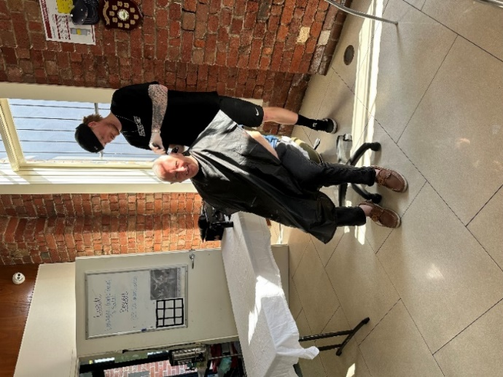
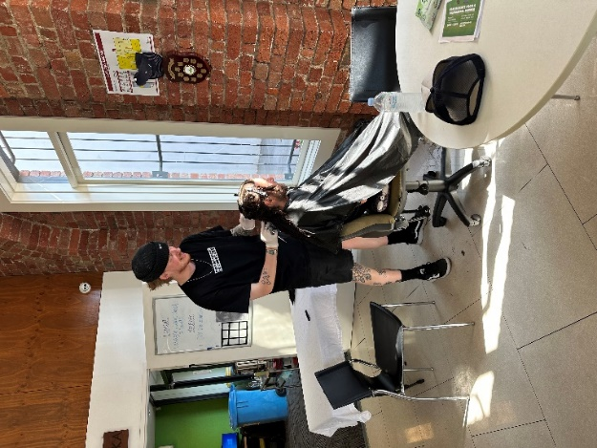
Free Haircuts

We have recently linked up with a local barber who is attending Open Place Drop-In Centre Tuesdays every 6 weeks. He will be available between the hours of 10am and 12pm to provide free haircuts to anyone registered with Open Place.

Samson the barber attended on 14 March and 2 May and some of the regulars enjoyed having a chat while getting a trim.

If you are interested or would like to know more, please call Open Place and ask to speak with Shaye. We will also update the Open Place website events page www.openplace.org.au/events with the upcoming dates.
Social support groups (SSGs)
Gippsland/Sale SSG
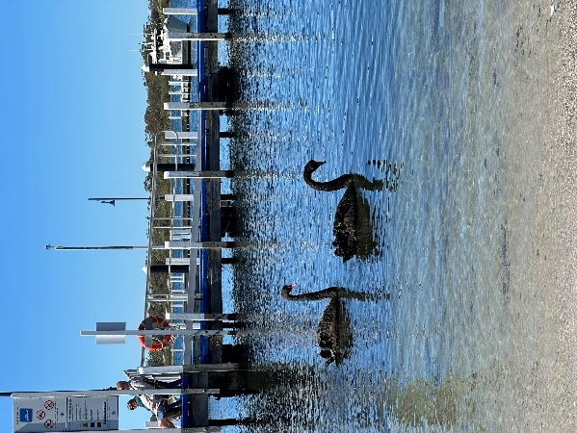
The Gippsland group have had a wonderful start to the year. In February, we had lunch at our home base in Sale and it was great to see everyone again after the Christmas break.
We had a fun outing in March where we took a cruise over Lakes Entrance, got to explore the lakeside village of Metung and enjoyed a tasty meal at the Metung Pub. The weather really shone for us on this day and the swans stopped by to say hello.
Due to the weather in April, we had to change our planned barbeque outing to the Lakeside Club instead.
We look forward to attending some fan favourite lunch spots over the next couple months.
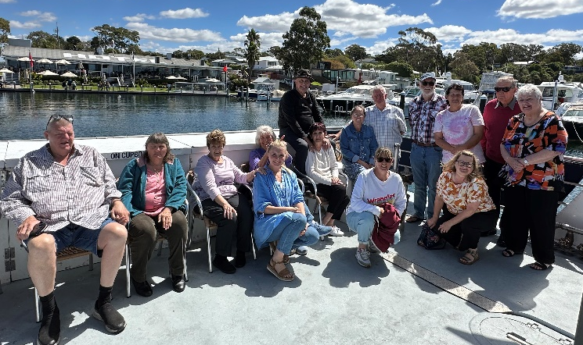
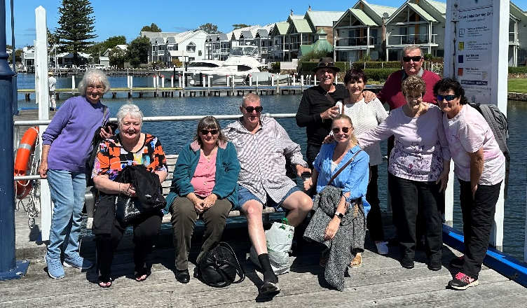
The Gippsland/Sale group meets every second Thursday of the month. For anyone who wishes to join the group, please call Open Place on 1800 778 379 to receive the monthly flyers by mail.

Frankston SSG

Frankston’s social support group’s most recent outing was a barbeque in March at Tooradin Foreshore. We had both a beautiful setting and good weather to enjoy. We even had a group member catch a slightly less than trophy-sized fish! We are hoping to visit the Dandenong Ranges for our next outing.
At our May gathering, one of our members celebrated a special moment in her healing journey by bringing amazing boxes of cupcakes to share with everyone. Thank you!
The group continues to regularly welcome new members. To those who have just joined, welcome. We look forward to getting to know you.

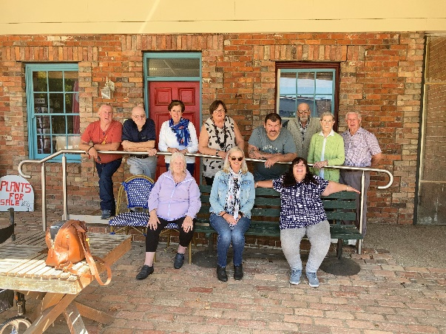
Donald and District SSG
The Donald and District Social Support group generally meet on the fourth Thursday of each month. We have changed a few dates to work around public holidays and staff leave. In the past few months group members have enjoyed lunch at Mount Jeffcott Hotel in Donald, Salingers of Great Western and a barbeque in Beulah. New members are welcome.

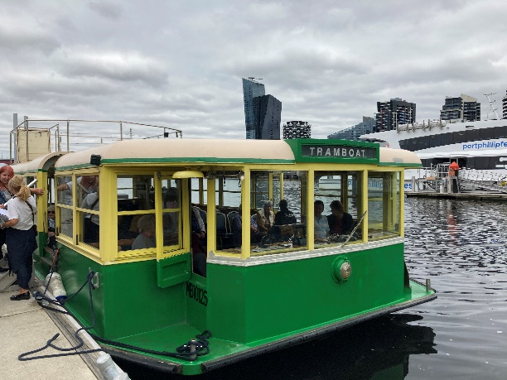
Bacchus Marsh SSG
Mary and Megan would like to thank all the Bacchus Marsh Social group members for a lovely end to 2022.
We celebrated in December with a Christmas-themed lunch at a local pub, where we enjoyed the roast lunch and had a bit of fun popping Christmas crackers.
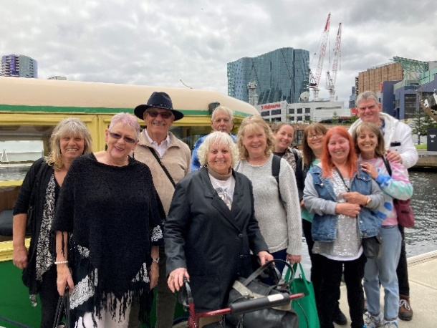
This year started with an outing on the Melbourne Tram Boat which took us on a relaxing cruise along the Yarra River to Williamstown.
In Williamstown, we were able to wander through the local shops before reboarding the tram boat to enjoy a delicious fish and chips lunch for the cruise back into Docklands.
We look forward to our catch ups throughout 2023.

Shepparton SSG
We hope you had a grand Easter and were able to ‘taste test’ some chocolate during the break.
Our first get-together for the new year was in February at the North Shepparton Community Hub. We saw quite a few of our members dust themselves off and come and join us for some delicious finger food which we arranged from Higgins Bakery in Shepparton. The party pies and sausage rolls are a group favourite, and we never seem to have too many leftovers by the end of the day. It was wonderful to see everyone and hear about their adventures over the Christmas/New Year break.
It was Cameron’s last time with us as Group Co-Facilitator, with Siobhan returning from maternity leave and re-joining the group in March. Much thanks to Cameron for all his assistance and contribution to the group; it was very much appreciated, and you will be missed.
Our March meeting was again held at the Community Hub and there was an air of excitement knowing that Siobhan would be back after being gone for 15 months. Siobhan and Tracey share the driving to Shepparton (from Melbourne), and Tracey was looking forward to stopping at Wallan for their routine coffee and (her) hash browns. We had a great turn out on the day; it was lovely to see so many of you for a chat and catch up over lunch. Dessert was a real hit with an exciting selection from Donut a GoGo in Shepparton. It was a lovely, happy day for everyone that was at the meeting.
In April, we planned a barbeque with the Wangaratta/Wodonga SSG at Benalla. The weather smiled down on us all – a beautiful day for it. There were about 35 people, including partners, who enjoyed each other’s company and dined on sausages, hamburgers, chicken ribs and salad followed by Easter eggs for dessert. We got there early to ensure we could lay claim to the two barbeques and tables and started cooking. There was lots of laughter, full stomachs and smiling faces by the day’s end. Thank you to everyone that helped with preparing and/or cooking on the day.
We look forward to continuing this tradition with the Wangaratta/Wodonga SSG and thank them for their company and hope they enjoyed the day as much as we did.
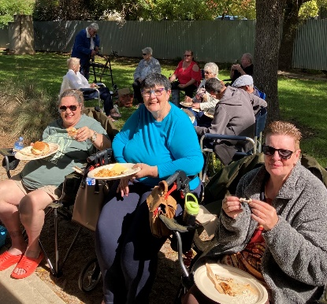
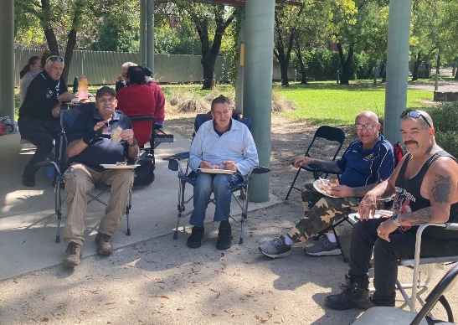
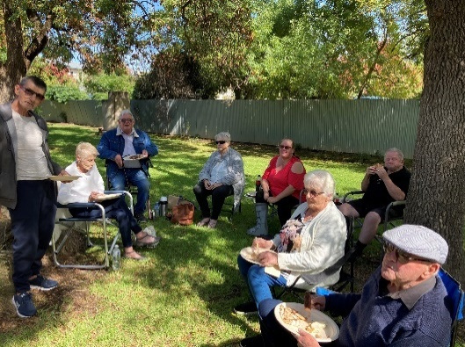
As always, we welcome anyone who is registered with Open Place and lives within the Goulburn Valley area to contact us if they are interested in attending the Shepparton SSG. Please ring Open Place on 1800 779 379.

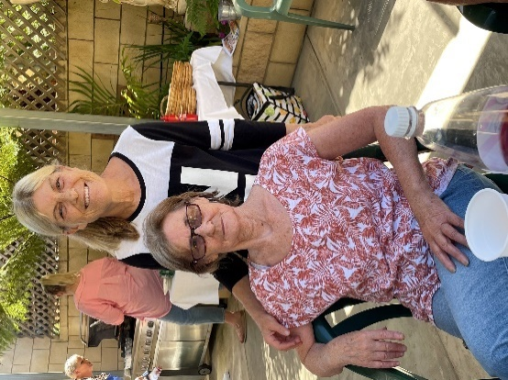
Bendigo SSG
If you live in the Bendigo area and have been thinking of coming along, please give Annie a call on 0427 695 600.
Our first get-together for the year was in February at the Long Gully Community Centre. We discussed the year ahead and enjoyed a meal together. In March, Colleen (group member) invited the group members to her home for a barbeque lunch and catch up. Thank you, Colleen, for opening your home to the gang!
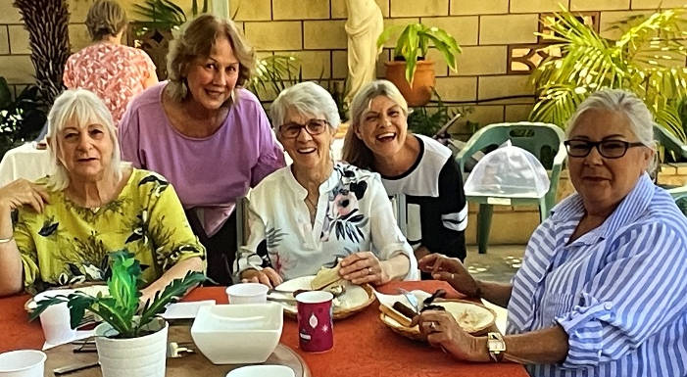
April was back at the Long Gully Community Centre where we enjoyed lunch together and eating Dolly’s Delicious Cream Kisses.
Dolly often makes cakes to share with the group.
Plans for our next meet-up are yet to be determined.

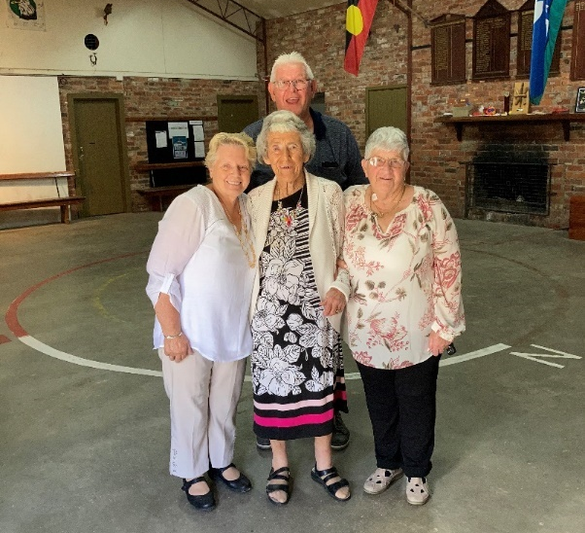
Wangaratta/Wodonga SSG
After a break in January, the group started up again in February in Wangaratta. We struggled against the heat and the noise of the GIGANTIC fans in the meeting hall, but it didn’t stop everyone enjoying the catch up after the Christmas/New Year break.
Cheryl and Rhonda brought Jean to the group. Jean was celebrating her 100th birthday! They are joined here by Stefan, who recently celebrated just his 70th birthday.
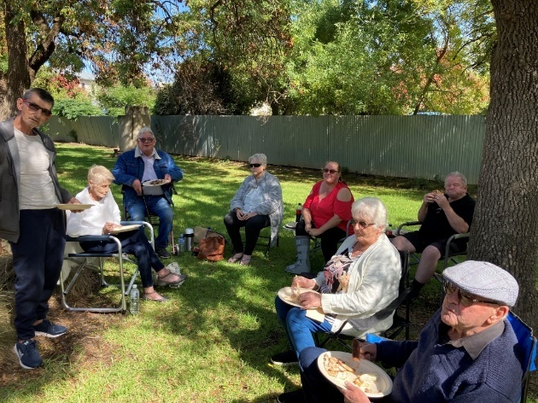
March saw us back at the regular meeting spot at Felltimber Community Centre in Wodonga. The group enjoyed a barbeque feast; special mention goes to Peter who did a great job at the grill. We got through the day without setting fire to anything!!
In April we made the trip to Benalla to meet up with the Shepparton group, which we hope will once again become a yearly event. We were blessed with a beautiful clear sunny day; we really got lucky as there was heavy rain every other day that week! The group was also pleased to see Munni from Open Place back in action again.
The Wodonga/Wangaratta group will usually meet on the second Wednesday on the month throughout this year. If you would like to attend or find out more, please contact Munni or Cameron at Open Place on 1800 779 379.


Horsham SSG
The Horsham SSG has met each month this year for lunch at various regional eating places including the Horsham RSL and most recently the Natimuk Pub in April.
Under the watch of Mt Arapiles at Natimuk, the group were impressed by the service at the Natimuk Hotel, especially the desserts – they gave the ‘Nati Pub’ the thumbs up! Future outings include Christmas in July and an outdoor event later in the year.
Horsham SSG welcomes any people registered with Open Place who are interested in joining the group, to contact Phillip Chalker on 0428 173 606 or Open Place on 1800 779 379.

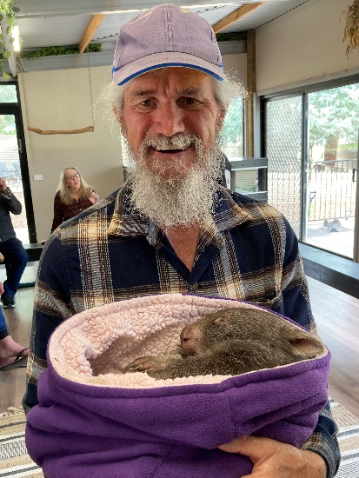
Warrnambool SSG
The first get-together for the new year was held in February at The Archie Graham Centre in Warrnambool. We meet at Archie bi-monthly on the first Wednesday of the month at 12 noon. On the other month, we go on an outing. If you live in the Warrnambool area and have been thinking about coming along, please give Annie a call on 0427 695 600.
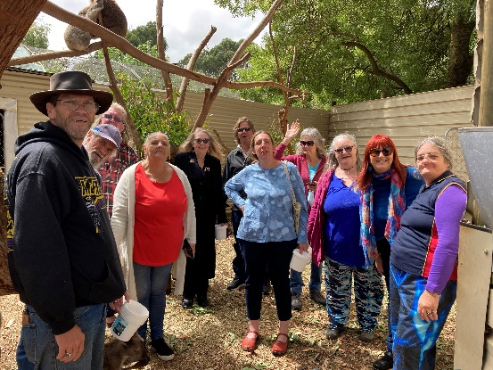
In March, the group went on an outing to the Cudgee Wildlife Park where we shared a picnic lunch and a cuppa in the park grounds. We were given an educational talk on conservation of our Australian native animals before those who wanted to, could cuddle a baby wombat, a ringtail possum or have a python around their shoulders. We then wandered around the free-range park having close encounters with emus, wombats, koalas and kangaroos. We also saw a barking owl (yes, an owl that barks like a dog).
In April, we were back at Archie Graham for a mosaic workshop where those present commenced an art piece each, to be finished in May – watch this space.
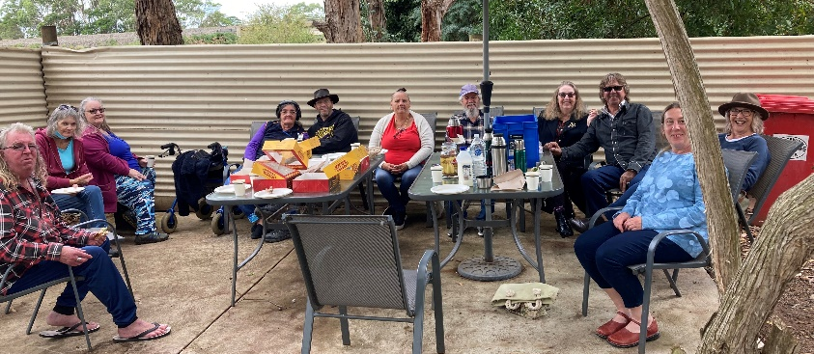
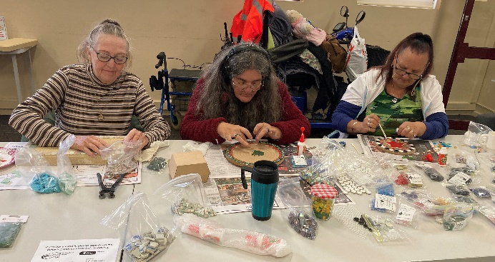
Our May catch up was cancelled due to the Warrnambool Races.

Geelong SSG
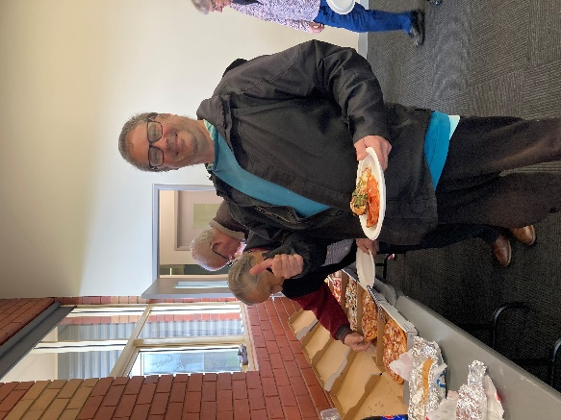
If you live in the Geelong area and wish to join our Social Support Group, please give Annie or Raymond a call on 1800 779 379.
In February, we met at our usual venue, the Grovedale Neighbourhood House in Heyers Road, Grovedale. We discussed future group outings and enjoyed a nice lunch together as well as a catch-up.
Raymond, Munni and the group had a big day out together in March. They all met in Queenscliff in the morning, then boarded the Searoad Ferry where they sailed the high seas across to Sorrento. The group was met by a bus to transport them to Arthurs Seat.
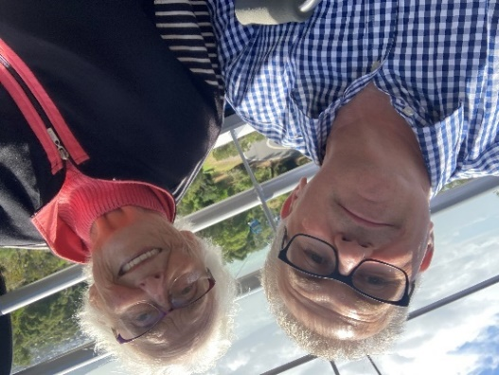
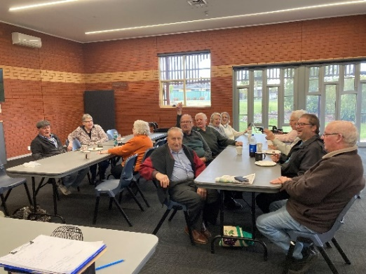
After a quick bite to eat, all present boarded the Eagle Gondola soaring high above the treetops with scenic views of the Mornington Peninsula. The day concluded with a bus ride to Sorrento and then back on the Searoad Ferry to Queenscliff. It was a great adventurous day out for all except for Raymond who was seasick not once but twice!
In April, we had a fun day
playing bingo at the Grovedale Neighbourhood House.
In May, we are having lunch at the Gateway Hotel.

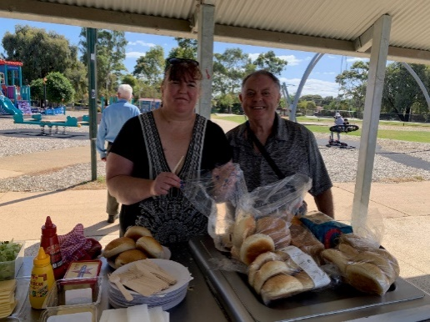
Preston SSG
In the last few months, the Preston group has enjoyed a barbeque in the park, the cinema and Morning Melodies at the RSL.
The barbeque was a lovely day out at Malahang reserve and the sun was shining.
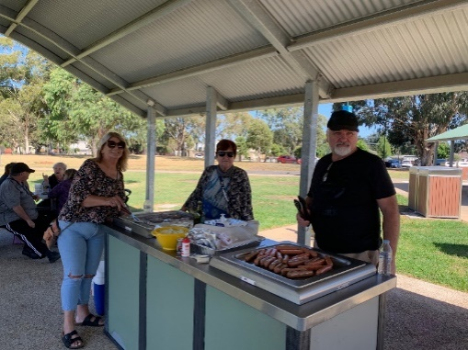
We were happy to see all group members who attended and a special thanks to those who cooked the burgers and snags for us all.
The group continues to meet each month, welcoming new group members as always. In the next couple of months, the group will be doing some planning for the next financial year.
The group meets every third Friday of the month.

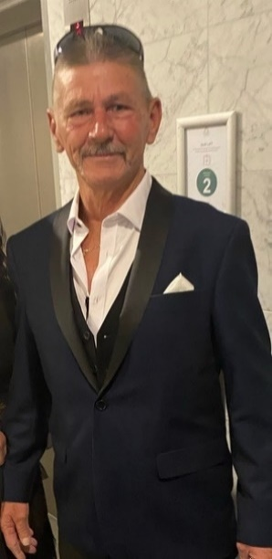
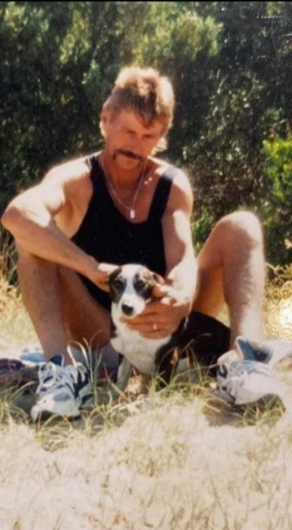
Vale Eddy
It is with sadness that we inform you of the passing of one of our group members, Eddy.
Eddy was always telling great stories about his life and he took a lot of pride in his garden. Eddy and Sandra once brought the group fresh vegetables and herbs from their garden to share.
We express our deepest condolences to Eddy’s family, and he will be greatly missed by Open Place and the Preston group.

Dandenong SSG
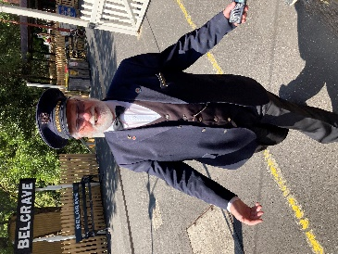
The Dandenong group’s first big outing for the year was in February to the Dandenong Ranges for a ride on Puffing Billy. It was a glorious day and many of us had been waiting in anticipation for this trip for some time. We took the bus from Noble Park to Belgrave where we boarded the train with a great degree of fanfare.
The trip was great with a lot of people on the train sitting with their legs out, including some of our group.
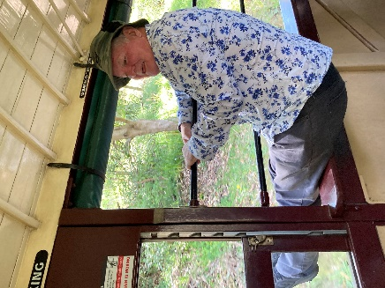
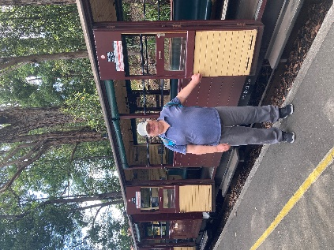
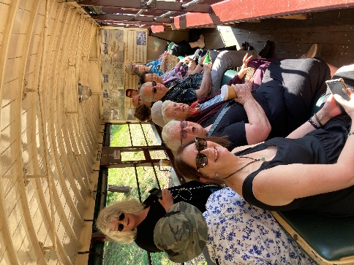
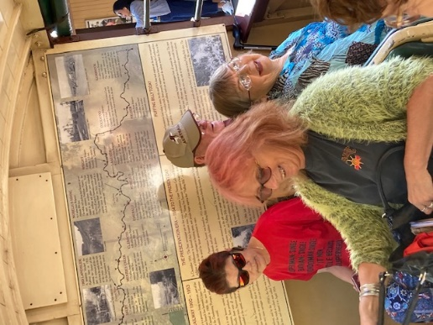
Lunch was at the new Visitor Centre which also houses a well-stocked merchandise shop.
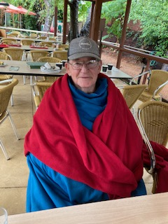
Following our lovely lunch, our bus came to collect us from Emerald Station and we headed back to Noble Park.
Our long-awaited visit to the Blue Lotus Gardens in March was unfortunately marred by inclement weather, however it did not dampen our spirits as there were plenty of lily pads on show and still a few lilies happily showing their lovely faces.
The management were well prepared for the chilly weather and supplied us with blankets and heaters while we had our lunch. Some of us were brave enough to walk the gardens and enjoy what was on display.
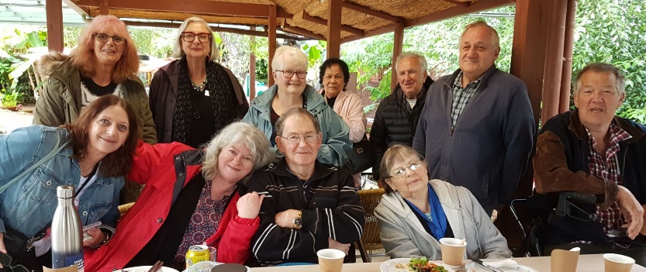
Our April group was in-house at our new place in Hampton Park. Homemade soups, rolls and cake with our cuppas was enjoyed by all and we had a resounding rendition from the group of ‘Happy Birthday’ for Paul, Pat (both well in their 80s) and Rani. We also had an impromptu game of charades and a rendition of ‘Show me the way to go home’ (with additional verse, “reworded”) – no names mentioned.
Missing from the photo shoot: Patricia, Daniel, John and Lorraine

Ballarat SSG
The Ballarat group has enjoyed some lovely get-togethers since our last newsletter update, a highlight being our trip to Sovereign Hill in March! The weather was perfect as we strolled around the site before enjoying a meal at the bakery. Several people made their way to the candy shop for some good ol’ boiled sweets, while others preferred to watch the Redcoat Soldiers march up Main Street with the military drumbeat, high hats and their guns.
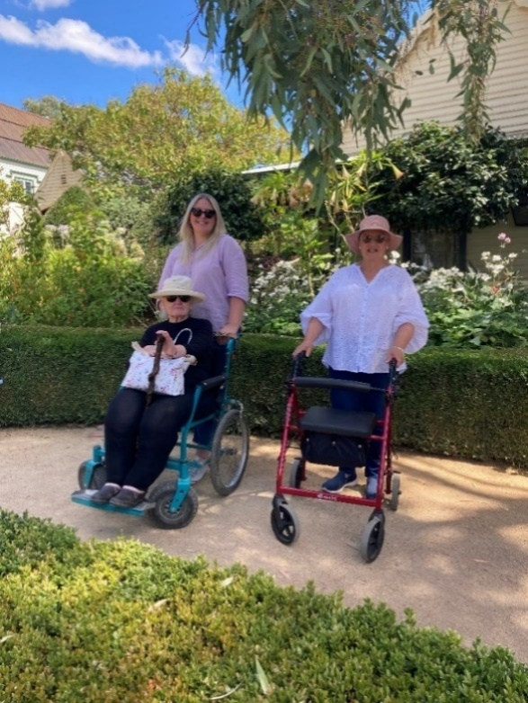
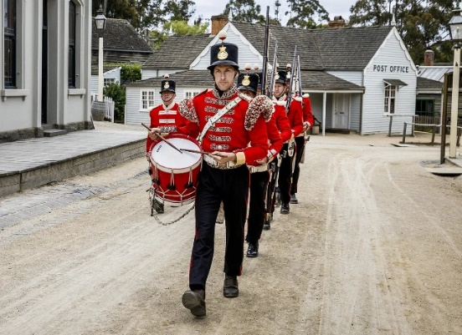
Ladies admiring one of the many beautiful cottage gardens
The Red Coats on their Main Street march

April saw the group meet for a casual get-together at the Sebastopol RSL. Our resident funny man had prepared a few jokes to keep the group entertained. Thanks for the laughs, John!
In May, we headed to the cinema to watch Book Club: The Next Chapter.
The Ballarat SSG meets on the second Tuesday of the month at the Sebastopol RSL. Please contact Open Place on 1800 779 379 if you would like to receive the monthly flyers.

Butterscotch pudding recipe


Ingredients
- ¾ cup brown sugar
- 1 ¼ cups self-raising flour
- 100g unsalted butter, melted
- 1 egg
- ½ cup milk
- 4 tablespoons golden syrup
- 1 tablespoon cornflour
- 1 ½ cups boiling water
- Cream or ice cream to serve

Method
- Preheat oven to 180 degrees. Grease ovenproof dish. Combine ¼ brown sugar and all of the flour in a bowl. Add the melted butter, egg, milk and 2 tablespoons of the golden syrup and stir until combined. Spoon into greased dish.
- Combine the remaining cup ½ cup of brown sugar and cornflour. Sprinkle over the pudding mixture.
- Combine boiling water with the remaining 2 tablespoons of golden syrup. Pour over the top of the pudding mixture and bake for 40-45 minutes or until a skewer inserted into the centre comes out clean.
- Serve with cream or ice-cream (or both!!).
Suggestions
Contact us
If you would like information about your current services or want to share your suggestions, find out how Open Place can support you, or subscribe to receive this newsletter by email, please contact us.
- Free call 1800 779 379
- Visit openplace.org.au/contact-us
- Email info@openplace.org.au
- Write to us at:
Open Place
Suite 1/8 Bromham Place
Richmond VIC 3121
We welcome any suggestions from you on how we can improve our service to better suit your needs.
Maybe you have some ideas for our social support groups, newsletter, Richmond drop-in centre or our workshops/activities.
Contact us and let us know. We would love to hear from you!

 |  | 
We acknowledge the pain and loss of childhood experienced by Forgotten Australians and we recognise the lifelong impacts of childhood trauma. | We acknowledge the Aboriginal and Torres Strait Islander peoples as the Traditional Owners of the lands and waterways of Australia. We support Aboriginal people’s right to self-determination and culturally safe services. | Open Place is committed to providing safe, inclusive and accessible services for all people.

